SOCIO-ECONOMIC
Business Consulting Report
[YOUR NAMES GO HERE]
Management 448/548 Spring 2016
Place Colorful IMAGE or PHOTO OF THE BUSINESS, & Your TEAM HERE
Client: name of business, client name, phone, and address
Prepared For Professor David M. Boje and Hank Strevel

Table of Contents (if you use WORD HEADING 1 AND 2 you get this).
PART I.
Part I: Executive Summary (1 page) 5
Three Main Consultant Recommendations 6
PART II. Report is organized in 23 Consulting Steps: 12
Step 1 - Diagnostic (A-spiral: Diagnostic, Project Plan, Implementation, & Evaluation of Results) 12
Step 2 Time Management Tool: Spiral B’s first tool 14
1st DYSFUNCTION: (Shift in Function) REDIRECT EXCESS TIME that is definitely not adding value to the business (its sales or services, its strategic outcomes); tasks or functions that need to be abandoned, transferred, DELEGATED, or eliminated. The client’s answers to D-questions (Dispersion & Detaching processes no longer needed) can be included here. This is where you get the time needed to do 3 to 5. 17
2nd DYSFUNCTION: (Regulation of Dysfunction) DEFICIENCY TIME – Time spent correcting mistakes such as rework, due to dysfunctions that could be resolved in production, marketing, cash-to-cash (i.e. time it takes to convert inputs to cash flows), inventory, ordering time, etc.. This includes lack of good habits of action. This is also where by resolving deficiencies in quality and productivity you get more time to do 3 to 5. 1st and 2nd Dysfunctions get resolved so that ... 17
3rd is More Value Added Time is available: Savall et al., (2008) calls it ‘Day to Day Management’– Time that adds value to the production of goods and services, to necessary functions. Teach clients to maintain these value-added habits of action. 17
4th is Prevention of Dysfunctions by pro-active use of tools (Time management, logbook of indicators, PAP, I/ESP, PNAC, & Spiral Updraft) and making the strategic and political choices (main directions, rules of the game, etc.) so 1st and 2nd dysfunction do not happen. Distracted owners who forget to prevent 1 (excess dysfunction) and 2 (deficient dysfunction) are spinning their wheels, putting out fires instead of preventing them. This also needs to become a habit of action. 17
5th is Creating Revenue Potential – Time on the Middle Path: This is two things. First, it is tending to the stem-roots of the business (Excess Salary, Overtime, Risks, Non-production, Over-consumption, & Non-creation of Potential Revenue). Second, it is the C-spiral, shaping the future with strategies that enhance revenue potential: main directions, rules of the game, expand the market, build capacity, advertise, market, etc. It is an investment of time in the future that a small business cannot do without, if 1 and 2 and 4 are out of control, or no #3 (value-added) is consistently happening. It is oftentimes the most neglected area, because there is no time left to do it, if 1-4 are out of control. Again, this needs to become a habit of action. Practice the reducing 1 & 2 in your own life so you have more time for 3, 4, and 5. Then teach it to your client. 17
Time Diary 17
Step 3 - Direction (C-spiral), which is also the 1st D-question (Directionality). 19
Step 4 - Project planning (A-spiral) done collaboratively with your client. 19
Step 5 - Strategic Piloting Logbook tool (B-spiral) 19
Step 6 – CHANGE PROCEDURES to change Rules of the game - (C-spiral) 20
Step 7 - D2 - Datability - What are the most important datable moments in the life story of the business? 20
Step 8 - Mirror Effect meeting with client (A-spiral, part of D-P-I-E cycle) 21
Step 9 - Implement project in collaboration with your client (A-spiral) 28
Step 10 - Priority Action Plan tool (B-spiral) 29
Step 11 - Resource Deployment (C-spiral) 29
Step 12 - D3 and D4 (Q-Spiral: Durability and Disclosability) 29
Step 13 - Evaluation (A-spiral) evaluate results of the project using the piloting Logbook indicators you have to date 30
Step 14 - Competency Grid (B-spiral) 30
Step 15 - D5, D6, D7 (Spiral: Destining, Deployment, & Dwelling) 31
Step 16 - Evaluation – (A-spiral) Evaluate Project # 2, Diagnostic, Project plan for 3rd project 31
Step 17 - I/E SP (Internal/External Strategic Plan) (B-spiral Tool 5) 31
Step 18 - More D's (Spiral: Deseverance & Drafts) 32
Step 19 - Complete the Evaluation (A-spiral) of the 3rd project 32
Step 20 - PNAC (Periodically Negotiable Activity Contract) 33
Step 21 - technological, product market, management systems, and develop human resources C-spiral 36
Step 22 - Last D's (Spiral: Dispersion & Detaching) 36
Step 23 - Spiral-Updraft 36
Virtue and Principal –Based Ethics SECTION OF REPORT 37
Conclusions and Recommendations 40
References 41

Part I: Executive Summary (1 page)
MetallicWind is a blacksmithing business owned and solely operated by Dr. David Boje. David forges metal into spiral-pens, wind sculptures, metal swords, pendants, cooper flowers, leaves and even heart-swords of Deseverance. David was inspired when he learned about his great grandfather William Henry Shelton from Goldendale, Washington, had a blacksmith and livery stable small business (D. Boje 2011). This secret was unveiled to him by his mother more than fifty years after his birth which planted the seed form him to get in touch with his roots. We can say in David’s terms that this was the beginning of an upward spiral. In 2008 David had built his own blacksmith shop outside his home out of straw bale with a metal frame and roof. Inside he houses a coal forge, propane forge, torch forge, power hammers of his own design, metal sheets, rebar, steel poles, anvil, and many more materials needed depending on his creation. Annual Sales (Estimated) Less than $500,000, sole proprietorship.

Three Main Consultant Recommendations
1. My first recommendation for David would be to create an identity for the company to grow and expand on. He would want a name that relates to the business such as the name metallic wind which implies something to do with metal and wind for the wind sculptures that David has invested so much time in creating as the foundation of his business. Recommend he use crowd funding; Lucky Ant's Crowdfunding for Small Businesses; RocketHub.org - The Community for Creative Crowdfunding
2. Second he would need to reach out to a community that is interested in items that he is creating. An online Etsy account would be the solution where people sell products of their own creation directly to their interested buyers. This is desevering the space between MetallicWind and the customer and can be accessed anytime in the virtual world. David has a shop at home but in a location that is not ideal for a business where when I went to visit saw about 2 cars pass by on my hourly sessions with him. With this exposer David will also need a website, but more than that he would want to be able to communicate with his consumers easily and pass on information about the business effectively. I have created a Facebook page which is linked to the Etsy account to allow easy access for customers on information about products and vice versa. After watching David craft different items I really believe that the crafting is an art of itself, and videos of him crafting are up on his Facebook account for customers to view. This will give customers an idea of how much David Cares about their products by the amount of time and work he puts in.
3. And finally the most important Recommendation would to give more time to the business which is as of right now more like a hobby for David rather than a business. David can only use his free time in the shop where most of it is spent being a professor at New Mexico State University and I would imagine it would be quite difficult to run a successful business on 5-10 hours a week max. Also David is very distinguished in his work of socioeconomic management where he is flown out of country at time to speak on the subject.
Introduction (4 pages) I will now introduce to the client, key consulting concepts, SEAM 4-leaf, A-B-C SPIRAL Model, and 3 D-P-I-E ‘s to create spiral of momentum for implementing SEAM, and summarize results of 3 mirror effect meetings (one for each D-P-I-E).

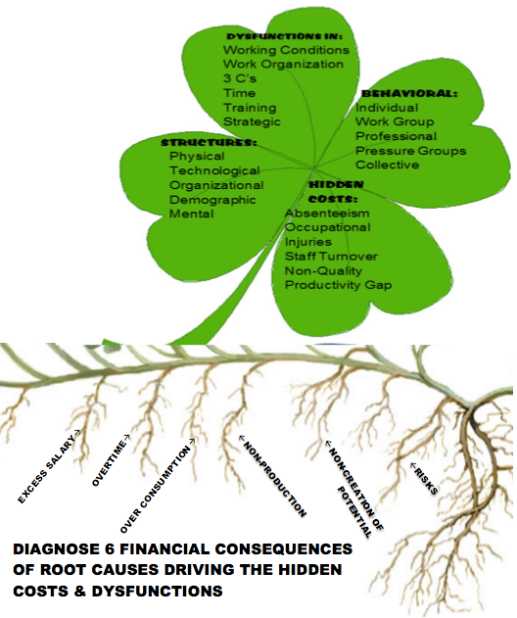
Figure 1- The SEAM Diagnostic Clover with Root Causes of Financial Situation of the Business
“Every system is perfectly designed to get the results it gets” (Hanna, 1984,1988).
The Business you are consulting with is ‘perfectly designed to get the financial results it gets. Why does a business continue to get poor results? The accounting and management information system has HIDDEN the ‘real story’ from the decision makers and is handing over a very shallow narrative in the income statement and traditional accounting storytelling. Therefore, the consulting approach is to LISTEN to the current face-to-face, and in-action storytelling, in-order-to unearth the DYSFUCTIONS, the HIDDEN COSTS, and the UNTAPPED REVENUE POTENTIAL so the client can LOOK IN THE MIRROR and see the ‘real story.’ The REAL STORY is in 6 FINANCIAL CONSEQUENCES that drive HIDDEN COSTS and RESULT FROM all the DYSFUNCTIONS:
FINANCIAL CONSEQUENCES OF THE WAY IT IS NOW:
- Excess Salary
- Overtime
- Over Consumption of Resources
- Non-Production of goods and services
- Non-Creation of human potential
- Risks that things will get worse and worse
Socioeconomic Approach to Management (SEAM) is a consulting intervention to unleash human potential to transform all the dysfunctions into positive financial consequences. Three forces of change occur as the small business consulting intervention winds its way through the spiral-axes: A three D-P-I-E interventions in 16 weeks, B six Management Tools taught to client, C Strategic Decisions to change six Financial Consequences.
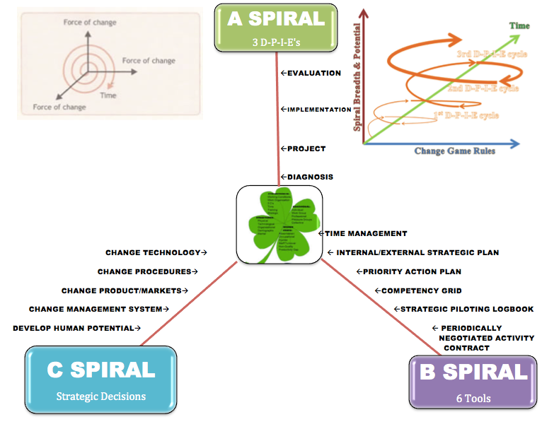
Figure 2- A-B-C SPIRALS OF Transformation of the business to achieve human potential (Adapted by Boje from p. 26 of Savall et. al 2008 book)
A business consultant tries to help the client create better processes, and those processes are spiraling, in good ways, and in bad ways. This is done by implementing 3 D-P-I-E cycles of improvement.
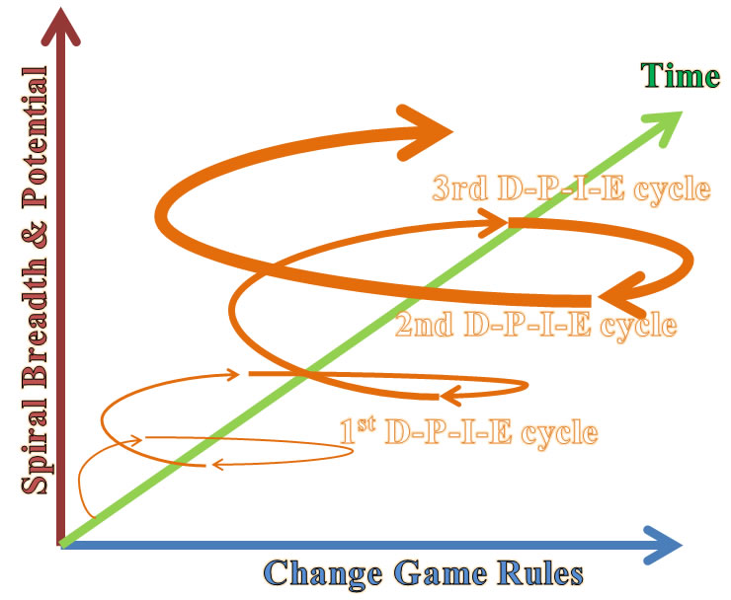
Figure 3 -Three D-P-I-E Cycles become an Upward Spiral of Continuous Improvement - Drawing by Boje July 6 2012
Implementing the mirror effect in an actual face-to-face meeting with the client where direct quotes from manager, employees, customers, and suppliers are displayed and discussed to diagnose areas that made need fixing, particularly stem-roots which are the cause of surface problems that the client is talking about. You report on this meeting at mid-term. With the mirror effect, you are able to use this diagnosis to come up with solutions and recommendations. Using direct quotes from the client, you can tell them reference them back to the problem and then what the underlying cause may be. This is helpful when giving recommendations because they are better able to see why you are recommending that solution. There are three components to mirror effect: presentation of direct ‘storytelling’ quotes (verbatim) sorted by managers, employees, customers, & suppliers; (2) a table of hidden cost and revenue calculations, and (3) the student consultant observations and recommendations.

PART II. Report is organized in 23 Consulting Steps:

Step 1 - Diagnostic (A-spiral: Diagnostic, Project Plan, Implementation, & Evaluation of Results)
This begins by you asking the 6 Domains of Dysfunction, then ask 11 D-questions (spiral D) which you are to tape-record or video-record and then meticulously transcribe the verbatim answers in your Midterm and Final Report.
Table 1 - SIX DOMAINS OF DYSFUNCTIONS CONSTITUTE FAMILIES OF THEMES & SOURCE OF IDEAS
1. What are the Working Conditions? Your activities? Your resources? Rewards? Work Space? Routinized? Chaotic? Poorly assigned tasks? Degree of multi-tasking? What improvements would you like to see? What are the sustainable and unsustainable practices?
2. What is your Work Organization? Bureaucratic? Mechanistic? Top-Down? Political? Flexible? Distribution of tasks? Promotion options? Lateral movement? What improvements are needed? How Green is this organization?
3. 3C's (Communication, Coordination, Cooperation). How is the communication? What are the concrete problems that result when 3C breaks down? What kind of formal contact exist (meetings, appointments, written communication, emails, screens)? What are existing circuits of informal contact? What improvements do you suggest? Current procedures that pose problems for delegation? Coordination? Scheduling?
4. Time Management? What is your typical work schedule at the moment? What constraints trouble your time management? Do you regularly schedule ahead of time? What concrete problems are encountered? What would your ideal time schedule be like?
5. Training? What are the tasks for which you experience lack of training? What are your competencies that are not being used? Is there Green training?
6. Strategic Implementation? For you what are the priority areas of general policy? Who decides what they will be? Would it be necessary to clarify certain objectives? If you notice a discrepancy between objectives and accomplishments, what do you do?
Business Sustainability Indicators- Include detailed storytelling, living stories of sustainability and any interventions made to implement sustainability logbook indicators
Each interview that lasts about an hour should generate at least 10 pages of hand-written verbatim notes. Please record full sentences, put quotes around each verbatim statement. Do not put things in your words, use theirs. These notes and observations of hidden casts (untapped revenues) are basis for doing your Mirror-Effect meeting with your client. Please Develop qualitative and quantitative LOGBOOK metrics of SUSTAINABILITY?

Table 2 – 11 D’s of Quantum Storytelling Questions
11 D's | Q to ask your client | Where it helps you Client Consultation
Directionality | 1. What is the directionality of the business processes; to what future are they headed? | Axis C: Direction. This is not compass direction; it is strategic direction, arriving from the future-->present.
Datability | 2. What is the datability of the business process developments? | 4-Leaf Structures: Important pivotal dates where technical processes, physical and other structures were acquired
Duration | 3. What is the duration of various business processes? | Axis C: Strategic Choices - helps sort out how long various strategies have been in effect
Disclosability | 4. What is the disclosability of the future business processes revealed to you? | Axis A - projects that disclose a future, Axis B - PAP and I/ESAP; SI in top leaf. The future is arriving into the present, presenting a set of potential futures, in the choice points in Axis C
Destining | 5. What is the destining of the processes unfolding in ways you can foretell? Follow up, in fore-caring, fore-structuring, fore-having, fore-conceiving. | Axis B: PAP & I/ESAP; Axis C - all items. This is weak destiny, where even where the is momentum and carved channels in the market, there are also choice-points among futures
Deployment | 6. What is the deployment of business processes, in-order-to, for-the-sake-of? | Axis B: PAP & I/ESAP; Axis C - all items. Look at existing processes of production, distribution, & consumption. How are these processes deployed. How could they be?
Dwelling | 7. What is the dwelling, in-place in the world of business processes? | Knowing place in the market, in the state, etc. lets them sort out Axis B: PAP & I/ESAP; Axis C - all items
De-severance | 8. What is the de-severance (de-distancing) of space-time-mattering? | De-severing space is bringing something far close. De-severing time can be bringing a future potential into the path of SAP and I/ESAP and the Axis C choice-points.
Drafts | 9. What are the drafts, updraft, and downdraft, into tighter (down) orbits, or into more open outer orbits (up), and the turning points from one draft to another? | Axis A, B, & C. This is where the client and consultant sort out strategic choice points, moving into more updraft spiral-antenarratives, ascending into more potential
Dispersion | 10. What is the dispersion of processes, too diverse, or consolidating them? | This can free up resources to invested in more strategic processes, letting go of low-value added activities
Detaching | 11. What is the detaching from being drawn into they-ness, they-relations, they-self and finding a path of ownmost authentic potentiality-for-Being-a-whole-Self? | Following the they-crowd is not great strategy. Developing into whole-Self potentiality fits well with Axis C
There are places in the steps that follow for you to include transcriptions of the D questions. For transcribed examples of answers to D questions, please see Boje's YouTube film on blacksmithing businesses.

Step 2 Time Management Tool: Spiral B’s first tool
Purpose of Cycle Time Redesign - The whole purpose of cycle time is to reduce the variances in-order-to decrease production time cycle, which in turn lowers personnel, inventory, and order costs (decreases returns), and up to a threshold, will increase product quality, increase production, and thereby increase goods available for sale. It is important to notice the variances, those disturbances, delays, and human errors that extend cycle time beyond what it could be. Reducing variance gets rid of non-value-added (NVA) tasks and steps, to streamline the production cycle.
First part of Time Tool - inventory every cycle in the business, and this will get you to an understanding of how from cycle-to-cycle, each time there is a difference, and that difference can be good, an improvement, such as upcycling, a value-added time, a quality time. Or time cycles can be very bad, lots of dysfunction, something at variance such as low quality, non-production, wasteful materials, higher costs, non-sustainability, such as downcycling. You will have to observe, cycle after cycle, not just measuring time on the clock, but the value-added of activities in a production cycle, a marketing cycle, inventory cycle-turns, cash-to-cash cycles (see Boje’s 2001 book, Quantum Spirals for Business Consulting).
Second part of Time Tool - based on your observations and interviews with lots of folks, figure out how management is using their time. Fill in the following chart, and put in quotes, stories you wrote down or recorded in the answers to D-questions. The last two D-questions and the one on Datability are good ones for this part of your report.

Figure 4 – The Five Aspects of Time (click on the figure above to change the image)
For example, the new time management after 3 interventions could look like this

1st DYSFUNCTION: (Shift in Function) REDIRECT EXCESS TIME that is definitely not adding value to the business (its sales or services, its strategic outcomes); tasks or functions that need to be abandoned, transferred, DELEGATED, or eliminated. The client’s answers to D-questions (Dispersion & Detaching processes no longer needed) can be included here. This is where you get the time needed to do 3 to 5.

2nd DYSFUNCTION: (Regulation of Dysfunction) DEFICIENCY TIME – Time spent correcting mistakes such as rework, due to dysfunctions that could be resolved in production, marketing, cash-to-cash (i.e. time it takes to convert inputs to cash flows), inventory, ordering time, etc.. This includes lack of good habits of action. This is also where by resolving deficiencies in quality and productivity you get more time to do 3 to 5. 1st and 2nd Dysfunctions get resolved so that ...

3rd is More Value Added Time is available: Savall et al., (2008) calls it ‘Day to Day Management’– Time that adds value to the production of goods and services, to necessary functions. Teach clients to maintain these value-added habits of action.

4th is Prevention of Dysfunctions by pro-active use of tools (Time management, logbook of indicators, PAP, I/ESP, PNAC, & Spiral Updraft) and making the strategic and political choices (main directions, rules of the game, etc.) so 1st and 2nd dysfunction do not happen. Distracted owners who forget to prevent 1 (excess dysfunction) and 2 (deficient dysfunction) are spinning their wheels, putting out fires instead of preventing them. This also needs to become a habit of action.

5th is Creating Revenue Potential – Time on the Middle Path: This is two things. First, it is tending to the stem-roots of the business (Excess Salary, Overtime, Risks, Non-production, Over-consumption, & Non-creation of Potential Revenue). Second, it is the C-spiral, shaping the future with strategies that enhance revenue potential: main directions, rules of the game, expand the market, build capacity, advertise, market, etc. It is an investment of time in the future that a small business cannot do without, if 1 and 2 and 4 are out of control, or no #3 (value-added) is consistently happening. It is oftentimes the most neglected area, because there is no time left to do it, if 1-4 are out of control. Again, this needs to become a habit of action. Practice the reducing 1 & 2 in your own life so you have more time for 3, 4, and 5. Then teach it to your client.

Time Diary
1st DYSFUNCTION: EXCESS TIME ON WRONG STUFF
- How much time do you spend putting out fires?
- How much time do you spend doing things others could be taught to do?
- How much time do you spend doing other people’s jobs that don’t show up?
2nd DYSFUNCTION: DEFICIENT TIME
- How much time do you spend correcting mistakes other make?
- How much time do you spend because materials are not right?
- How much time do you spend in rework?
3rd More Value Added Time
- How much time do you spend that is adding value in the long-term?
- How much time do you spend expanding your market?
- How much time do you spend innovating?
- How much time do you spend implementing strategic moves?
4th PREVENTING DYSFUNCTIONS
- How much time do you spend training so dysfunctions do not happen?
- How much time do you spend creating systems that work well so dysfunctions don’t keep happening again and again?
- How much time do you spend listening to people you work with so you learn together to stop dysfunctions before they happen?
5th CHANGING THE STRATEGIC DECISION TIME
- How much time do you spend changing the direction of this business, so you get results you want to get?
- How much time do you spend changing the rules of the game (procedures, policies)?
- How much time do you spend reploying resources needed to get job done right?
- How much time do you spend developing new technology processes to get it done right every time?
- How much time do you spend developing the kind of flexible, agile management system that stops the bureaucracy, so you getting to success?
- How much time do you spend developing human potential?
- How much time do you spend developing a sustainable business (profit, people, & planet)?

Step 3 - Direction (C-spiral), which is also the 1st D-question (Directionality).
Put the transcribed answer here. Keep in mind your consulting focus: to help your client move out of many dysfunctions and poor root-stems, and using the savings and income potential, construct step-by-step an Updraft-Spiral. This means sorting out direction in the C-spiral, asking about choice-points, when at the cross-roads, which way will the client be turning? Ask about the directionality, not from the past to present, but from the future. Strategy foretells the future. It is not a repetition of the past (that is aimless). Think strategically, and act it. Ask: How is the future arriving, and what is the array of futures that are potentially available? There is never just one future, except in linear/cyclical thinking. The cycle never just repeats itself exactly. Silly rabbit. Even the continuous cycle time and quality improvement folks know the cycles do NOT really repeat, instead they spiral. It is time to notice how the last cycle is not the same as this one, to note the differences, so you notice the choices. It is all about the differences. It is noticing differences just arriving, like the customer coming in wanting a slightly different product or service configuration. Noticing the flows of action, that is the second sort of storytelling. That is what choice-making is all about. What? The action-storytelling, where there are no words said at all. So you will need to observe the direction, not just talk about it. Look at the processes in place, unfolding, and the direction of their transformation, and what transformations are arriving.

Step 4 - Project planning (A-spiral) done collaboratively with your client.
What project can you and the client implement quickly, without a lot of resources, by freeing up the time you found in Step 2. Teach the D-P-I-E of A-spiral, and get ready to do three of them.

Step 5 - Strategic Piloting Logbook tool (B-spiral)
Please begin creating indicators with your client so you can measure progress (qualitative and quantitative indicators help to pilot the direction). Indicators are as simple as deadlines, mileposts, number of new customers, number of web hits, etc. Add in some sustainability indicators: power usage (a simple indicator is the electric bill, the water bill), power waste (lights left on, water wasted), power sources (find some sustainable ones), and cut the waste by recycling, reducing, reusing, etc. You won't know where you are going or if you have arrived, unless you create some indicators. Don't leave it to the accountant. Do some ABC or your own (Activity Based Costing) by figuring out the hidden costs of the business doing as it has been doing on all those four leaves of the clover. Your storytelling notebook has entries about how to track things and serves as your SPILB. Develop 5 types of indicators (include qualitative & quantitative) for IESAP, PAP, etc. pp. 126-129 in Savall et al (2008) book. The piloting of a small business depends on reading indicators to know if the spiral is upwards or downwards, if the business is making or losing money, if customer returns and rework is decreasing or increasing, and so forth.
Type 1: EVERYDAY PERFORMANCE INDICATORS for SPL:
  - Internal Activity - e.g. volume of activity in a given day, week, month, or year. Examples: number of pfoducts, deliveries, repoaris, amount of waste, delays, and each of the root-downsurge-spirals (excess salary, overtime, overconsumptin, nonproduction, noncreation of potential, & risks) (see p. 33).
  - External Activity - e.g. scanning the business environment, being vigilant about competitors and the quality of materials from suppliers, new technologies, and other items on Axis C.
  - The Immediate Results - Quantitative indicators like costs, revenues, direct sales revenue, costs of repairs, dysfunction costs (absenteeism, occupational injuries/diseases, staff turnover, nonquality, & direct productivity gaps) (see. p. 33).
Type 2: CREATION OF POTENTIAL - INDICATORS for SPL:
  - Evolution Activity - e.g. Two lists: First a list of actions that implement the IASAP in this period of PAP by specifying schedule and who will do what when, and why. Second, a list of dysfunctions to be prevented based on Axis A Diagnostic. There is a multi-skilling going on here where people in the small business are learning to identify dysfunctions and root-stem-downsurge-spirals and to implement value-added TM, and to be vigilant with SPL. This relates to the CG tool, since some of these competencies must be learned. It it relates to Axis C, which is all about evolution activity of scanning the environment and making changes.
  - Activity Linked to PAP - e.g. Make a list with your client of developmental actions (above evolution activity list and dysfunction list_ and specify what is to be implement by whom, when, and why on the PAP chart (see chart below).
  - Activity directly Creating Potential - e.g. indicators of qualitative or quantitative nature of how potential is being created, how dysfunctions are being prevented, how downsurge-spirals are being up-rooted, and how employees are being multi-skilled in SEAM tools, including TM, SPL, and PAP.

Step 6 – CHANGE PROCEDURES to change Rules of the game - (C-spiral)
Business is a game and it is time to change the 'rules of the game.' There are choice points in the political and strategic decision making of every business. What game is being played in action, in the weaving of actions among the actors and the actants (things, technologies, equipment, mattering)? Who is making the game rules? How can rules be changed (ethically, See Aristotle 350 BCE, Virtue Ethics on line)? Are the rules of the game ecologically sustainable?

Step 7 - D2 - Datability - What are the most important datable moments in the life story of the business?
Transcribe and put here those living stories of what is emerging, unfolding in the Now, not just the rote narrative of the past. Record them by tape and or video. This can be done on the first field visit. Most students don't pay attention to the first set of life stories the client says in that first interview. I think students have been trained not to pay attention to living stories, and look instead for the quick solution, and thereby miss the spiral altogether. A life story is primordial, from birth to death, and you are in the middle of yours, not dead yet, still alive, and already born, on some sort of pathway, even if you never thought about it. There are datable moments in your future, such as graduation, the next job, perhaps a wedding, children, etc. Datable moments are happening in your future, and arriving in your present, just as much as the datable moments from the past are arriving in the Present. People always capitalize the Present, but not the past nor the future. I think they know that with each newness in the Present, that emergence opens up a rehistoricizing of datable moments past, and opens up futuring so what you think will be the milestones shift in your landscape, and new ones are beckoning you to approach.

Step 8 - Mirror Effect meeting with client (A-spiral, part of D-P-I-E cycle)
Where you feedback the living stories and quotes sorted by stakeholders, present a hidden costs and untapped potential revenues chart based on questions asked in the 4-leaf diagnosis; and make 3 consultant observations and recommendations. This is a long meeting, a meeting about the text, the scripts you collected from employees, clients, suppliers, and whomever you could access. And it is your observations put into field notes on all those visits. Not a note taker? OK, get a good tape recorder, one with dual microphones (stereo microphones), and start recording conversations, in meetings, in interviews, wherever you have permission. By the time your mid-term arrives, you are advised to have the Mirror Effect face-to-face meeting with your client. It is where you point out the costs and lost revenues of behaving, structuring, etc. and how much dough they can have, and peace of mind, if they find what Aristotle (350 BCE) calls the middle path, the one between excess and deficiency, which is by the way the definition of all those dysfunctions you analyzed in the upper leaf of the 4-leaf.
Mirror Effect (Diagnosis) – And it is most important section in mid-term & final report where you put in all your posted entries from your field Storytelling Notebooks (5 by mid-term, 5 more by final). Please use storytelling standpoint methodology. You collect the stories (verbatim dialogue) and you tell the stories in a Mirror Effect meeting with your client. They listen because you also share the costs and lost revenues that are happening by continuing to do just as they are doing, and all the lower costs and untapped revenue potential that comes from doing a project with you. Mirror Effect (Savall et. al, 2008: pp.66, 149) is defined as the direct quotes and the storytelling recorded from stakeholders (copied out of your Storytelling Notebook interview & observation verbatim quotes), your own Expert Opinions (ibid, p. 66), & hidden revenue/hidden cost. I will give two examples.
Table 2 – Report for MIRROR EFFECT Meeting (Required Summary Table of Costs of Keeping Going the Way its Going)
Dysfunction, Structure, Behavior, Hidden Cost OBSERVED | Frequency of Each | Estimated Cost of each Occurrence | SUBTOTAL of Cost & or Untapped Revenue | Reasons for Each | IDENTIFY ROOT-STEM: DOWNWARD ECONOMIC PERFORMANCE SPIRALS
1. HC: Absenteeism | 3 times a week | $50 | $150 | Had to have owner do job of absent printer | Excess Salary Spiral
2. Dysfunction: Time Management | 1 time each week | $100 | $100 | Printers wasting time | Overtime Spiral
3. Behavior: Conflict of two press operators | 2 times a week | $50 | $100 | Behavior: two operators are fighting | Overconsumption Spiral (wasted paper)
4. HC: nonquality | 2 times a week | $500 | $1,000 | Dysfunction: the communication of specs for the job from clerk to printer was wrong | Nonproduction Spiral (customer refused job)
5. Behavior: Professional Categories | 1 time a week | $400 | $400 | Dysfunction: Work organization | Noncreation of potential Revenue Spiral
6. Dysfunction: Integrated Training | Once a year | $1,000 | $3,000 | Operator not trained on paper cutter; payout in workers’ comp | Risk Spiral: some apprentice lost a finger
TOTALS:  WEEK  MONTH  YEAR TOTAL |  |  | $ 1,750  $ 7,000  $87,000
Here is another example of this sort of Table.
Table 3 – reporting 2nd MIRROR EFFECT Diagnosis –
Dysfunction, Structure, Behavior, Hidden Cost OBSERVED | Frequency of Each | Estimated Cost of each Occurrence | SUBTOTAL of Cost & or Untapped Revenue | Reasons for Each | IDENTIFY ROOT-STEM: DOWNWARD ECONOMIC PERFORMANCE SPIRALS
1. Dysfunction:  Work conditions | 3 x/wk | $25 | $75 | Time and energy spent accessing items in disorganized office | Overtime (extra time spent doing non-value producing activity)
2. Dysfunction: Communication-coordination-cooperation | 4 x/wk | $20 | $80 | Failure to or miscommunication of expectations to assistant | Excess salary (time is spent clarifying or communicating instead of producing)
3. Dysfunction: Work organization | 3 times a year | $3,000 | $9,000 | Not having enough staff to increase client volume | Nonproduction (potential clients lost due to lack of staff)
4. HC:  non-quality | 2 times a year | $3,000 | $6,000 | Website needs to be dynamic in order to catch people’s attention | Nonproduction (potential clients lost due to refined image)
5. Dysfunction: Time management | 10 x/wk | $10 | $100 | Time spent transitioning between unrelated tasks | Nonproduction (time spent doing nonrevenue creating activities)
6. Dysfunction: Strategic implementation | 2 times a year | $4,000 | $8,000 | Failure to capitalize on investors looking to buy very low priced housing | Nonproduction (loss of potential buyers)
TOTALS:  Weekly  Annual  YEAR TOTAL |  |  | $ 255  $ 23,000  $36,260

(Also please see p. 55 Figure 5.2, p. 58-9, Figure 5.23 & 5.24 through p. 62 Figure 5.25.c; and in Chapter 6, p. 86 Figure 6.7, Appendix 3 & 5 for several other examples of Creation of Potential and Hidden Cost Calculation forms as templates to use in Mirror Effect if they are more appropriate).
Here are some examples of how to insert transcribed answers to questions and observations into your report from Charmayne Thomas’ 2011 report:
Direct Quotes:
Tara: “The shop just isn’t busy enough to stay open all those hours; I don’t miss but maybe one customer if that.” Also, “If I have something come up like my child needs cookies for class or help on a big project, I’ll close the shop to go home because that is more important to me than the one or two orders that I might miss.”
Mary Ann: “People will call me at work and ask if the shop has closed down or when we will open again because it is closed every time that they go there.”
Merri: “The flower shop is just a family business that barely makes enough money to support itself. When a family member needs a job for some extra money, they can get a job there. It only pays minimum wage, which is probably less than you deserve, but it usually is helping both parties regardless. Tara started working in 1996 as the only employee except during holidays or busy seasons when the rest of us would be there working along with her. She didn’t like the minimum wage, however. In 2006, she quit because it didn’t pay enough, so I took over her job and started doing the daily orders. In 2007, Tara came back to work, but Mary Ann (the owner) and her have always been a little on edge since then. Mary Ann is afraid to tell Tara anything because she doesn’t want her to quit again or to cause family problems.”
Merri: “We used to advertise at the high school and have deals for students around Prom and other formal dances. We’d get around 100 orders for each dance. Now, we are lucky to get 10 orders.”

Here is student example of Mirror Effect from a 2011 report by Alyssa Reynolds

The first dysfunction is described in the following question:
Seems like your biggest issue is a productivity gap?
At the office, everyone always comments on my organization, but at home my office is a mess.
How much time do you feel that you waste to the mess?
It’s more of an energy drain not to be neat and clean.
I believe that time spent thinking about, or avoiding the mess could be better allocated to productive activities. The upfront cost of this process would be worth the long term addition to productivity.
The second dysfunction:
Are there ways that you could improve the effectiveness of your assistant?
Give her more hours. As my business level and income increases she will be doing more of what she is doing already. There is not much else I want her to do right now. She’s very efficient, and we’re working on creating a listing checklist for all the new listings to ensure that ALL of the steps are taken care of.
Is she going to be maintaining those lists?
I’m creating them, and she will maintain it and be thorough. Most of the tasks involved she is doing. Sometimes there is confusion about what things she is expected to do, because if I take a listing on Friday, I will go through and do some of the things I otherwise would expect her to do.
Is there a centralized place you could keep these lists?
We keep them in the office in a file. We do need to create a centralized online storage system for files like this. I trust her to do it, it’s just a matter of communicated to her that it needs to be done. –Something else I’m going to check in to is a team software called Top Producer. They have a centralized storage place for information. I’d actually like to be able to use the E-edge software.
This indicates that communication could be improved through the addition of new technological structures which would enable effectiveness of both Laura and her assistant.
The third dysfunction is a lack of organizational structures that result in an inability to seek and embrace growth:
What is your biggest fear of increasing your effectiveness?
This is a business where you cannot afford to let things slip through the cracks. You cannot make mistakes. This is the biggest financial decision in a person’s life, and it is emotional. I cannot afford to be so effective in gaining clients that I mess things up.
If you were to increase your clients, it would affect the quality of your business?
I am more concerned about legal issues. In fact, you can wreck your business.
The fourth dysfunction is a need to step up the impact of the website in order to better utilize a new tool:
Do they have additional tools you have considered investing in?
I pay an 8% franchise fee. They are creating a virtual agent service that will make it easier for people to get all of my information.
This new tool, will allow people to access listing information directly from Laura’s site, using a smartphone. If she is on the forefront of this technology, she could attract new listings and buyer clients.
The fifth dysfunction encountered is as a result of a failure to block time. As described by Laura below:
Describe your time management practices:
“How would I describe it? The first thing that comes to my mind is my Top Gun coaching class that I took. One of the classes is time blocking which is something I want to do. People who are self-employed tend to do this. I’d like to set up my time to spend this hour doing phone calls, this hour doing e-mails, but part of the reason I got in to this business was to have a flexible schedule for my kids.
“Disjointed with room for improvement, but effective
“Being a mom has always been my priority, as long as I have kids at home.”
The sixth dysfunction is a focus on listings for clients. Though listings create a REALTOR’s ® solidification in the market, not acquiring investors trying to capitalize on the downturn in the market is a loss. Also, these investors could create valuable referral possibilities.
Right now what are you looking to do or working on to improve your business?
Taking more listings. List to exist
What are some of the ways you are doing that?
Calling on expired’s, referrals, For Sale By Owners
Out of those techniques, which is most effective?
Referrals.
Part of Mirror Effect is the Structures and Behaviors. Here is a good example from the KLMX consulting report:
Right Leaf: Atrophied Behaviors:
Individual- “Everyone works individually when they are performing their job duties. The DJ is busy playing the music, I am working the daily logs, and the manager is working the bills, and working with our clients.”-Geoffrey Maestas
Work Group- “No matter what, at some point the employees have to work together. The radio station can’t run, without team work. There aren’t many employees, so it’s not that difficult to work together.” –Geoffrey Maestas
Professional Categories- The categories within KLMX are owner, manager, music/production director, and DJ.
Pressure Group- There is no organized groups within or external to KLMX.
Collective- Facebook.

Left Leaf: Atrophied Mental Structures:
Physical- There is one location from which all business activities are conducted. “There’s an office for the manager. There’s a control room where the DJ sits. We have a production room where we record everything and its sound proof. And then we have an open office with two different desks for operations.”- Geoffrey Maestas
Technological- “We upgraded our systems a couple years ago. In a way it’s good, but in a way it’s bad. It’s good, because during the night we can put the program in and leave it. Then music just plays till we get back in the morning, but it’s also bad because it has become overly used. We don’t do as many live shows as we used to. For instance we have lost that fun aspect of the business…….So if the internet goes out with the new system, we have no radio, because with the new system and the radio runs in unison with the internet.” - Geoffrey Maestas
Organizational- The employees that work at KLMX work together, but each employee plays a significant role in the operations of the radio station. The radio station only has three employees. The manager is responsible for handling bills, selling advertising, and marketing. The music/production director handles the day to day activities. These activities being the music being played throughout the day, the recordings and making sure the radio station is staying on schedule. The DJ is responsible for the news and the weather, as well as, direct interaction with the community.
Demographic- Clayton, NM and its surrounding areas only have one radio station, KLMX. Therefore the demographics for the station are all ages. The community as a whole tunes into KLMX to hear local news, local games, and music.
Mental- A grass-in-the-head person, writes Boje, has "a desire to be an assemblage of animal herds, family clan, orchards, beehives, and crafts." A tree-in-the-head person, he says, "can only think from beginning stage to end stage, from root to branches in developing strategy, plans, designs..."”( http://www.huffingtonpost.com/mike-bonifer/cenk-uygur-has-a-tree-in-_b_946062.html ).
We believe KLMX to be on its way to being a “grass-in-the-head person” because of their desire to work more closely with the community. They want to be the force with which brings the people of the community together and helps find value within each individuals business. In a sense they want to bring each unique family of the community together and make it one big bright herd with which will become a shining example of how a community should run.

Step 9 - Implement project in collaboration with your client (A-spiral)
Good advice, but many a student consultant has ignored it. Implementing a Project that the client is not on board with will lead to many headaches, even hard feelings. Clearly the spiral updraft is tugging you in a more amenable directionality. You did the Diagnostic, the Project plan, and now it is time to Implement and collaboratively, please. You are not here to be a slave. You are consulting, so they can do this on their own, with their own resources. This is first of three Projects (check your PNAC, and may be time to renegotiate, so you have three small changes in projects that are doable).

Step 10 - Priority Action Plan tool (B-spiral)
Please lay out three goals and action plan and who implements what for the next year (Savall et al, 2008: pp. 95-98). Goal 1 could be the first project, you have some basis for setting the PAP in motion. Doing (by workers) and Thinking (by owners) can become separated. The result of this sort of division of labor is a deterioration of “intellectual… virtues” of workers (Marx, 1867, Vol. 1, Chap 14, P. 362). As Marx puts it “division of labor … is an effect of past, and a cause of future progress” (ibid, p. 363). We don’t want linear PAPs. We want spirals of uplift of profits and revenues. Savall et al (2008) recommend involving workers in the PAP process, which in turn sharpens their Planning and Thinking in relation to their Doing. This way the spiral starts uplift by involvement by the ‘spurring of energy, decentralization, synchronization, while of course, enhancing vigilance.
Table 4 – Priority Action Plan Tool (adapted from Savall et al, 2008: p. 100).
STRATEGIC AXES | OBJECTIVES | PRIORITY ACTIONS | PEOPLE CONCERNED | JAN | FEB | MAR | APR | MAY | COMMENTS
 | 1. Crowd Funding proposal Lucky Ant's Crowdfunding for Small Businesses; RocketHub.org - The Community for Creative Crowdfunding
 | 2.
 | 3.
PRINCIPLES: | Spurring Energy |  | Decentralization | Synchronization |  |  |  |  | Enhancing Vigilance

Step 11 - Resource Deployment (C-spiral)
This will ome from making priorities, cutting back here, and expanding in the implementation of project (step 9). PAP gets implemented with the cost savings and enhanced revenues you promised in the Mirror Effect meeting. Deployment is part of the Q-Spiral set of questions, so go back and listen to your recording.

Step 12 - D3 and D4 (Q-Spiral: Durability and Disclosability)
Ask about durability of the various processes of production and distribution. Then ask about disclosability of the future arriving at their doorstep, to tell what sort of processes need to be fore-structured.

Step 13 - Evaluation (A-spiral) evaluate results of the project using the piloting Logbook indicators you have to date
Then renew the Diagnostic, and Project # 2 gets planned, and implemented. And do 2nd Mirror Report for Project # 2 as part of that diagnostic.

Step 14 - Competency Grid (B-spiral)
It is time to assess existing competencies of each person in the firm, and do a second grid of what competencies are needed to get the business in uplift to their PAP and 2nd Project Implementation. This also gets them set for the longer range strategy coming up. (Savall et al, 2008: pp. 98-100). Develop a grid of people by their existing competencies, and a second one show the competencies needed to implement the PAP and IESP.
COMPETENCY GRID BEFORE THE CHANGE
 | Traditional Competencies in old objectives |  |  |  | New Competencies to be Acquired
WORKERS | Green Product Design | Green Supply Chain | Materials Recycling | Energy Savings | Product Knowledge | Contracts | Project Management | Customer Service
A | ■ | ☐ |  | ☐ | ■ | ☐ | ☐ | ■
B | ☐ | ☐ |  | ☐ | ■ | ☐ | ■ | ■
C | ☐ |  | ■ |  |  |  | ■ | ☐
D | ☐ | ☐ | ■ |  |  | ☐ | ☐
E | ■ | ☐ | ■ | ■ | ■ | ☐ |  | ☐
F | ■ |  | ■ | ■ |  | ☐ | ☐ | ☐

COMPETENCY GRID AFTER THE CHANGE
A | ■ | ■ |  | ■ | ■ | ☐ | ☐ | ■
B | ☐ | ■ |  | ■ | ■ | ☐ | ■ | ■
C | ☐ | ☐ | ■ | ■ |  |  | ■ | ☐
D | ☐ | ☐ | ■ |  | ■ | ☐ | ☐ | ☐
E | ■ | ☐ | ■ | ■ | ■ | ■ | ☐ | ■
F | ■ | ■ | ■ | ■ | ■ | ■ | ☐ | ■

=Frequently Practiced  =Occasional Practiced/Not all Mastered
☐=Knowledge of Principles without Practice BLANK= No Knowledge or Practice

Step 15 - D5, D6, D7 (Spiral: Destining, Deployment, & Dwelling)
Time to ask the big quantum questions: What destining are they courting? How are they deploying to meet it? What is their place (dwelling-in-the-market-place and in sustainability with the Natural environment)?

Step 16 - Evaluation – (A-spiral) Evaluate Project # 2, Diagnostic, Project plan for 3rd project
And get into Implementation where the client is implementing and you are doing quite little activity.

Step 17 - I/E SP (Internal/External Strategic Plan) (B-spiral Tool 5)
Now that you have 2 projects completed, and a 3rd underway, it is time to take a turn in the path (Savall et al, 2008: pp. 93-5). Make a chart similar to PAP but over longer time horizon. This is a five year strategic plan with three long term objectives, action plans, who does what when, with more logbook indicators set up to measure their progression. The PAP was one year of the 5 years. This is the big game change, and it’s a way to get things to spiral instead of repeating same old stuff. Objectives are about sustainability, products, technology, developing human potential, market expansion, etc.
I/E SP (Internal/External Strategic Plan)
OBJECTIVES | 2016 |  | 2017 |  | 2018 |  | 2019 |  | 2020
 | Spring | Fall | Spring | Fall | Spring | Fall | Spring | Fall | Spring | Fall
OBJECTIVE 1:

Actions to fight against depletion of resources

OBJECTIVE 2:

Actions to increase human potential

OBJECTIVE 3:

Actions that create SUSTAINABILITY

Step 18 - More D's (Spiral: Deseverance & Drafts)
OK the de-severance removes distance so the far in space and time and mattering are near (ready-to-hand in the business processes). Drafts are force fields in the upon the spiral-antenarrative. It is like a glider-plane, where you float looking for new updrafts, and avoid the downdrafts. If the business has been in a downdraft, descending, then they will welcome the updraft. Your job is to help the client find the updrafts, and make the moves in the processes to get in place, to take that uplift pathway.

Step 19 - Complete the Evaluation (A-spiral) of the 3rd project
Adjust the Logbook indicators, PAP, and Competency Grid, so there is a smooth passageway to the I/E SAP. E.g. The three main recommendations are the organization of the home office, the development and implementation of integrated lists for organization as well as implementing time blocking so Laura can better utilize her time. By implementing these strategies, the Laura Reynolds Group has access to more time that is spent assisting current clients and developing relationships with potential clients. The hidden costs and unrealized revenues of these three activities are around 13,260 dollars a year, and if Laura and her assistant lost one average sized commission enacting these changes, their net gain would still be roughly 10,260 dollars.

Step 20 - PNAC (Periodically Negotiable Activity Contract)
A-spiral. This is at several levels. It is a PNAC between consultant and client, so expectations stay eye-to-eye over course of the 3 projects. Second, it is a PNAC training that you do with the client so PNAC's are used in the business with all the employees. And it is about compensation. If the employee helps move the firm into updraft, into more money, more customers, more revenue, less waste, etc, then what is going to be the reward, the payout for them. How do they participate in the good times? Yes it is profit-sharing, but also accountable for any of those six root-stems under the 4-leaf. By now the client should be familiar with all 6 tools and using them to pilot their business on the upward spiral-antenarrative path. If they are just repeating the same old business cycle, then your consulting has not worked. (Savall et al, 2008: pp. 108-112). This is the student consultant’s 3 main goals, action plans, and indicators for one semester. Teams can use the format of Table on p. 110 of Savall et al., 2008.
PNAC (Periodically Negotiated Activity Contract)
NAME:________________________________ for 6 MONTHS
☑-Focus on your targets; negotiate ways to do them
☐-PNAC connects with PAP, Strategic Indictors & Economic Balance
-Economic balances compare cost of means to reach objective with returns once targets have been attained (in terms of potential gains)
☒-$$ incentives self-financed by reduction in hidden costs
Types of Objectives | Objectives | Weighting (of 100%) | Target Level | Means | Metrics
CLIENT’S GENERAL TARGET | ☐-Increase in Veteran Theater Attendance | ___% | What: | How: | ☐-
CLIENT’S  COLLECTIVE PRODUCTION TARGET | ☐-Increase in Veterans Theater Ad Sales | ___% | What: | How: | ☐-
Your TEAM TARGET | ☐-Increase productive use of Radio/Press | ___% | What: | How: | ☐-
INDIVIDUAL # 1 TARGET 1 | ☐-Involve my SEAM skills in above | ___% | What: | How: | ☐-
INDIVIDUAL # 2 INDIVIDUAL TARGET 2 | ☐-Greening SOS Teaching Academy | ___% | What: | How: | ☐-
INDIVIDUAL # 3 INDIVIDUAL TARGET 3 | ☐-2 Quarter Horse Grant implementation | ___% | What: | How: | ☐-
INDIVIDUAL # 4 INDIVIDUAL TARGET 4 | ☐-2 Book project | ___% | What? | How: | ☐-

Step 21 - technological, product market, management systems, and develop human resources C-spiral
Time to make some choices, some are political and others are strategic. To change C-spiral is also lead Q-Spiral (which is also the 11th D of Quantum Storytelling) is quite the accomplishment.

Step 22 - Last D's (Spiral: Dispersion & Detaching)
As the business enters new up-paths then there is dispersion of processes, some of which are not all that helpful in the road ahead. And you as a consultant are detaching, getting ready to end your gig with the client. And the client is achieving potentiality-for-Being-a-whole-Self, not imitating competitors, not doing the ‘they-self’ walk. Fining that unique sense of freedom in the updraft, is a major result that you and your client can be proud of.

Step 23 - Spiral-Updraft
Submit your final Report to client and instructors. What value-added did your work with the client lead to in terms of up-draft-Spiral? You are done. Make your presentation; get along on your pathway. Be sure to draw some Spirals with bridges, off-shoot-fractals, and not those lame looking f-spirals with single line looping this way and that.

Virtue and Principal –Based Ethics SECTION OF REPORT
In this section I relate observations and examples of Aristotle’s (350 BCE) virtue ethics. Here is an example from Joe Padilla and Ashley Sexton’s 2011 report:
“For without friends no one would choose to live, though he had all other goods; even rich men and those in possession of office and of dominating power are thought to need friends most of all; for what is the use of such prosperity without the opportunity of beneficence, which is exercised chiefly and in its most laudable form towards friends?”

Virtue ethics as it applies to KLMX is having friends within their community who support and help keep the radio station thriving. KLMX would be non-existent if it wasn’t for the relationships KLMX has formed with friends of the community and the surrounding areas.

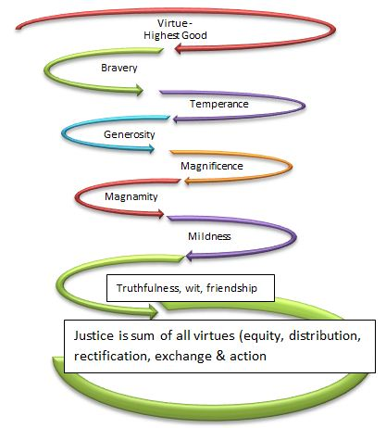
Figure 13 – Virtue Ethics Spiral Source Boje 448/548 Study guide # 1, http://business.nmsu.edu/~dboje/448/quiz1_studyguide.html
These next virtue ethics quotes and summaries are from a 2011 report by Britani Balkwin and Leslie Sanchez:
- 1st Book “action and pursuit is thought to aim at some good” Katia’s aim is to better the general public’s health. She has both a short term goal as well as a long term goal. The short term goal is to expose the idea of better health to NMSU students as well as young adults. The long term goal is to have at least 1000 health coaches in the El Paso area.

- 2nd Book “if then there is some end of the things we do, which we desire for its own sake, and if we do not choose everything for the sake of something else clearly this must be the good and the chief good.” Although Katia markets Take Shape for Life, she genuinely cares about getting people healthier and helping them make better decisions to improve their health.

- 3rd Book “Now each man judges well the things he knows, and of these he is a good judge. And so the man who has been educated in a subject is a good judge of that subject, and the man who has received an all-around education is a good judge in general.” Not only is Katia educated in both midwifery and public health she also has experience in both field.

- Certified professional midwife
- Licensed midwife in Texas and New Mexico
- CPR, Neonatal Resuscitation Certified
- Bachelor of Arts Degree in Linguistics (UTEP)
- Master of Public Health in Maternal child health and International Health (Tulane University school of public health)
- Completed Midwifery program (Maternidad La Luz)
- Permaculture and Massage Training
- Nursing program
- Traveled abroad to Europe, Mexico, and east Africa (training village health educators)
- Attended about 500 births since 1990

- 4th Book “It is not easy for the liberal man to be rich, since he is not apt either at taking or at keeping, but at giving away, and does not value wealth for its own sake but as a means to giving.” Katia has drastically improved her health as well as lost 130 pounds with Take Shape for Life. She coaches her clients as they also go through the program; this helps because she has already been successful with the program so she can answer many questions her clients may have. She has found a way to lose weight, keep it off, and also get healthier in the process; now she is able to spread the word and help others do the same.

5th Book “And it is complete virtue in its fullest sense, because it is the actual exercise of complete virtue. It is complete because he who possesses it can exercise his virtue not only in himself but towards his neighbor also; for many men can exercise virtue in their own affairs, but not in their relations to their neighbor.” As mentioned before Katia has been through the Take Shape for Life Program and it was one of the only programs where she reached her health/weight loss goals. She chooses to reach out and help other people with their goals with a program that she knows firsthand that will work.

Conclusions and Recommendations
Wrap up your report in a few pages and talk about the spiraling processes you did to bring about change and the small business’ spiraling-antenarrative development, as you see it.
Please put in original spiral drawings to close out your report, showing what has been accomplished, and what might be the future. Here are a few examples from previous reports.
Spiral diagrams of prior reports. The examples are of f-spirals; please develop D-spiral drawings for your reports this semester.
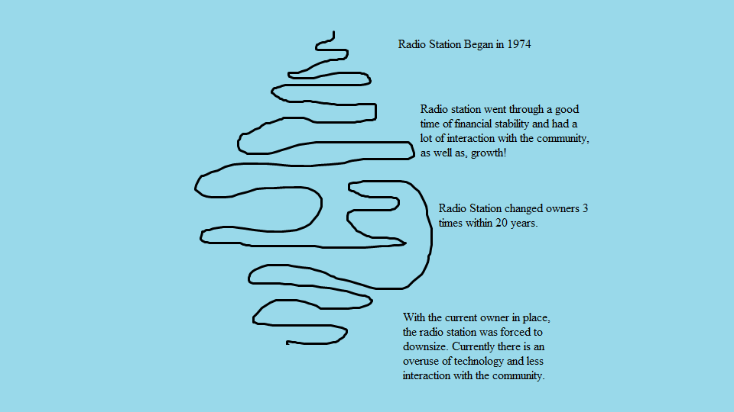

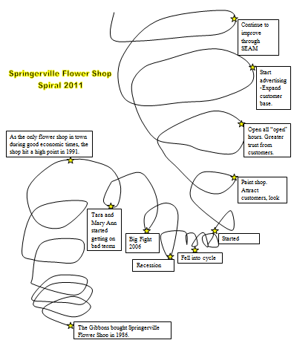
Figure 15 – f-spiral (again while this is one thing to include in your report, please draw a D-spiral with more inter-weaves, off-shoots, and dynamic relationships
Finally, please include references to material used to write your report.

References
Aristotle (350 BCE). Nicomachean Ethics. Translated by W. D. Ross. On line version http://classics.mit.edu/Aristotle/nicomachaen.html or use 456k text-only version is available for download.
Boje, David. (2012). Quantum Storytelling. Accessed online at http://peaceaware.com
Franken, Arnoud; & Braganza, Ashley. (2006). Organisational forms. International Journal of Knowledge Management Studies, Vol. 1, No.1/2 pp.18-37.

Heidegger, Martin. (1962). Being and Time. Translated by J. Macquarrie and E. Robinson. NY: Harper and Row publishers.
Latour, Bruno. 2005. Reassembling the Social: An Actor-Network-Theory. New York: Oxford University Press.
Savall, Henri, Zardet, Veronique, & Bonnet, Marc. (2008). Releasing the Untapped Potential of Enterprises Through Socio-Economic Management. ISBN 978-2-917078-12-9 2nd Revised edition, 2008. London: International Labor Organization and France: Socio Economic Institute of Firms and Organizations.

